Case Study 1

Title: Development of a College Department Webpage Using HTML, CSS, and JavaScript

Program Code:-
<!DOCTYPE html>
<html lang="en">
<head>
<meta charset="UTF-8">
<meta name="viewport" content="width=device-width, initial-scale=1.0">
<title>Symbiosis Institute of Technology</title>

<style>
* {
margin: 0;
padding: 0;
box-sizing: border-box;
font-family: "Segoe UI", Arial, sans-serif;
}

body {
background: #f8f5f5;
color: #222;
}

/* HEADER */
header {
background: linear-gradient(135deg, #8b0000, #c62828);
color: white;
padding: 55px 20px;
text-align: center;
}

header h1 {
font-size: 42px;
font-weight: 700;
letter-spacing: 0.5px;
margin-bottom: 12px;
}

header p {
font-size: 17px;
opacity: 0.9;
letter-spacing: 0.5px;
}

/* NAVIGATION */
nav {
background: #ffffff;
display: flex;
justify-content: center;
gap: 45px;
padding: 20px;
box-shadow: 0 4px 15px rgba(0, 0, 0, 0.08);
}

nav a {
text-decoration: none;
color: #8b0000;
font-size: 15px;
font-weight: 600;
position: relative;
}

nav a::after {
content: "";
position: absolute;
width: 0;
height: 2px;
left: 0;
bottom: -6px;
background: #c62828;
transition: 0.3s;
}

nav a:hover::after {
width: 100%;
}

/* MAIN */
.container {
width: 88%;
max-width: 1000px;
margin: 55px auto;
}

/* CARDS */
.card {
background: #ffffff;
padding: 40px;
margin-bottom: 30px;
border-radius: 18px;
border: 1px solid #eee;
box-shadow: 0 12px 35px rgba(90, 0, 0, 0.08);
transition: 0.3s;
}

.card:hover {
transform: translateY(-4px);
box-shadow: 0 18px 40px rgba(90, 0, 0, 0.12);
}

.card h2 {
color: #8b0000;
font-size: 26px;
margin-bottom: 18px;
}

.card h2::after {
content: "";
display: block;
width: 45px;
height: 3px;
margin-top: 9px;
background: #c62828;
border-radius: 5px;
}

.card p {
line-height: 1.8;
color: #555;
font-size: 16px;
}

/* BUTTON */
.student-btn {
margin-top: 25px;
padding: 14px 28px;
border: none;
border-radius: 8px;
background: #9b111e;
color: white;
font-size: 15px;
font-weight: 600;
cursor: pointer;
transition: 0.3s;
}

.student-btn:hover {
background: #6f0000;
transform: translateY(-2px);
box-shadow: 0 8px 18px rgba(139, 0, 0, 0.2);
}

/* STUDENT INFORMATION */
#studentInfo {
display: none;
margin-top: 25px;
padding: 28px;
background: #fff8f8;
border-left: 4px solid #9b111e;
border-radius: 10px;
}

#studentInfo p {
display: flex;
justify-content: space-between;
padding: 12px 0;
border-bottom: 1px solid #eee0e0;
color: #333;
}

#studentInfo p:last-child {
border-bottom: none;
}

#studentInfo strong {
color: #8b0000;
}

/* FOOTER */
footer {
background: #690000;
color: white;
text-align: center;
padding: 25px;
margin-top: 60px;
font-size: 14px;
}

/* RESPONSIVE */
@media (max-width: 650px) {

header h1 {
font-size: 30px;
}

nav {
gap: 20px;
}

.container {
width: 92%;
}

.card {
padding: 28px;
}

#studentInfo p {
flex-direction: column;
gap: 5px;
}
}
</style>
</head>

<body>

<!-- HEADER -->
<header>
<h1>Symbiosis Institute of Technology</h1>
<p>Department of Computer Science and Engineering</p>
</header>

<!-- NAVIGATION -->
<nav>
<a href="#department">About the Department</a>
<a href="#student">Student Information</a>
</nav>

<!-- CONTENT -->
<div class="container">

<!-- ABOUT DEPARTMENT -->
<section class="card" id="department">

<h2>About the Department</h2>

<p>
The Department of Computer Science and Engineering at
Symbiosis Institute of Technology focuses on developing
strong technical knowledge and practical skills in
computer science. The department provides students with
opportunities to learn programming, software development,
artificial intelligence, data science, and other modern
computing technologies.
</p>

</section>

<!-- STUDENT INFORMATION -->
<section class="card" id="student">

<h2>Student Information</h2>

<p>
Click the button below to view student details.
</p>

<button
class="student-btn"
onclick="showStudentInfo()"
id="studentButton"
>
View Student Information
</button>

<div id="studentInfo">

<p>
<strong>PRN</strong>
<span>24070521154</span>
</p>

<p>
<strong>Name</strong>
<span>Urwashi Dhawas</span>
</p>

<p>
<strong>Program</strong>
<span>B.Tech CSE</span>
</p>

<p>
<strong>Year</strong>
<span>Third Year</span>
</p>

<p>
<strong>Email</strong>
<span>urwashi@example.com</span>
</p>

</div>

</section>

</div>

<!-- FOOTER -->
<footer>
© 2026 Symbiosis Institute of Technology
</footer>

<script>

function showStudentInfo() {

const information =
document.getElementById("studentInfo");

const button =
document.getElementById("studentButton");

if (information.style.display === "none" ||
information.style.display === "") {

information.style.display = "block";
button.textContent = "Hide Student Information";

} else {

information.style.display = "none";
button.textContent = "View Student Information";
}
}

</script>

</body>
</html>

OUTPUT:
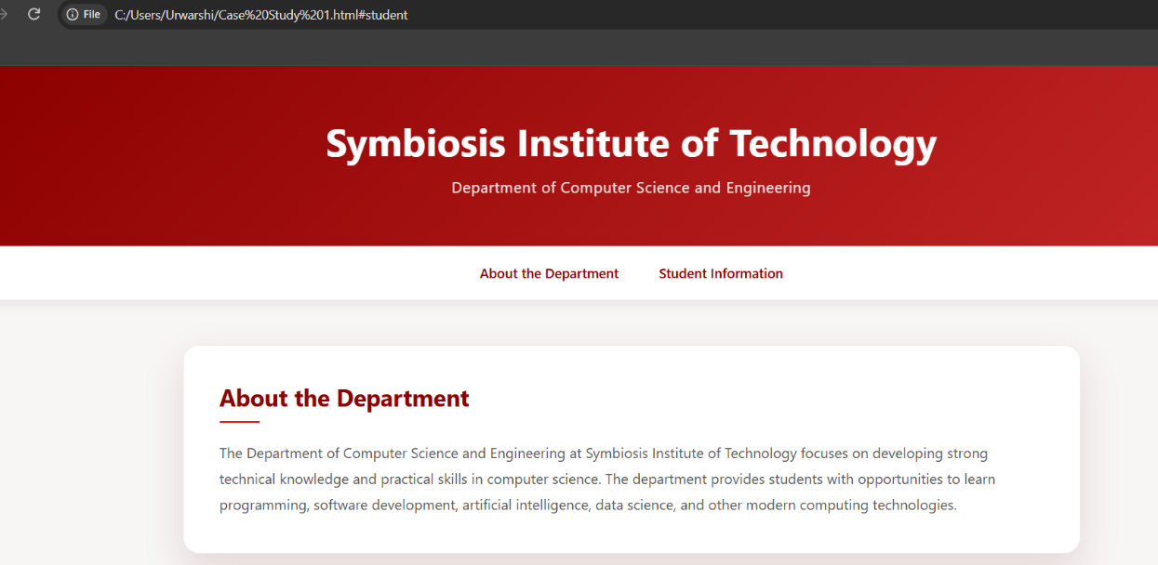
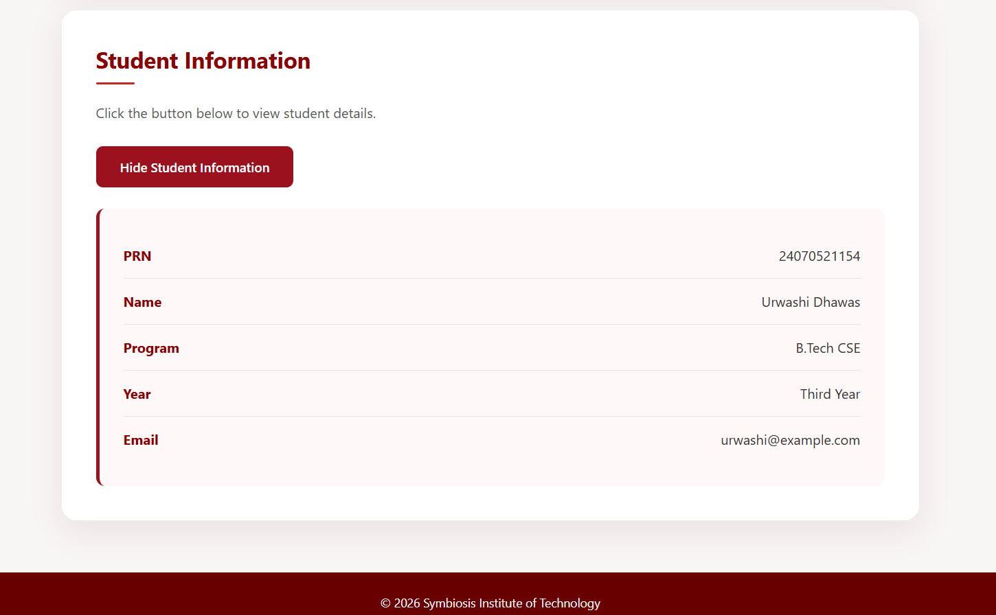

Result/Conclusion:
Successfully developed a professional and aesthetic college department webpage using HTML, CSS, and JavaScript with interactive student information

